**Industrial Internship Report on**

**”Healthcare Data Management”**

**Prepared by**

**ASHWINI S HALAKI**

| *Executive Summary* |
| --- |
| This report provides details of the Industrial Internship provided by upskill Campus and The IoT Academy in collaboration with Industrial Partner UniConverge Technologies Pvt Ltd (UCT).  This internship was focused on a project/problem statement provided by UCT. We had to finish the project including the report in 6 weeks’ time.  My project was Healthcare Data Management system.  This internship gave me a very good opportunity to get exposure to Industrial problems and design/implement solution for that. It was an overall great experience to have this internship. |

**TABLE OF CONTENTS**

1. Preface .................................................................................................................................................... 3
2. Introduction ............................................................................................................................................ 4
   1. About UniConverge Technologies Pvt Ltd ......................................................................................... 4
   2. About upskill Campus ........................................................................................................................ 8
   3. Objective .......................................................................................................................................... 10
   4. Reference ......................................................................................................................................... 10
   5. Glossary ........................................................................................................................................... 10
3. Problem Statement ............................................................................................................................... 11
4. Existing and Proposed solution............................................................................................................. 12
5. Proposed Design/ Model ...................................................................................................................... 13
   1. High Level Diagram (if applicable) ................................................................................................... 13
   2. Low Level Diagram (if applicable) .................................................................................................... 13
   3. Interfaces (if applicable) .................................................................................................................. 13
6. Performance Test.................................................................................................................................. 14
   1. Test Plan/ Test Cases ....................................................................................................................... 14
   2. Test Procedure ................................................................................................................................. 14
   3. Performance Outcome .................................................................................................................... 14
7. My learnings ......................................................................................................................................... 15
8. Future work scope ................................................................................................................................ 16

# 1 Preface

Summary of the whole 6 weeks’ work ,

> FIRST WEEK As a Intern , I learnt a quite information and knowledge about “UniCoverge Technologies Pvt.Ltd” which is also providing internship, and also in which technologies and domains it is working.The pdf provided by UniConverge was helpful to get a knowledge on the company as well as cloud computing topics and basics of cloud computing like AWS ,Azure ,Google cloud and many more applications during this week.

>SECOND WEEK was about all the actual main topics of cloud computing. Introduction to cloud computing , benefits , services models and Deployment models Which is one of the main topics .The Architecture about front end and backend of core components was the best applications that is consumed on cloud . In general , the cloud service models like Saas,Paas ,Haas about software and hardware organization throughout was learnt . The pdf and a vedio’s covered by teacher was even more helpful which was provided by UniConverge on cloud computing and also attended the quiz at the end of this week

>THIRD WEEK Upskill campus internship week 3 was about less topics but a vedio of how to create a AWS account, hardware required and library installation , data upload to AWS and creating thing ,policy creation and attach policy to things and certificate too . I tried to create my AWS account but there was a problem of my debit card, so couldn’t create it I’ll try further .

> FOURTH WEEK 4 was about firstly about Top eight exciting AWS projects and ideas for beginners , here I learnt quite about the projects that are related to the daily bases that is worked upon cloud computing.Then getting started with Thingspeak cloud Introduction to cloud , benefits , services models Which is one of the main topics and a lot more in it .Introduction to AWS-IOT Core includes the core concepts of AWS which in depth of the Architecture about core components that is consumed on cloud . In general , the vedios on live sensor data upload to IBM BLUEMIX cloud service about software and hardware organization throughout was learnt . The vedio’s covered by teacher was even more helpful which was provided by UniConverge on cloud computing .

> FIFTH WEEK 5 was about the vedio’s on soft skills like communication skills, Time management, Leadership, Critical thinking, Teamwork, Adapability , inter person skills. Then comes the Art of public speaking which is being bold in the public. Key points for interview was explained in detail. The on campus and off campus placements for fresher to enter into the IT World. Success ladder to the corporate world was all about the interview part. How a software engineer can be go through organization was learnt. The vedio’s covered by teacher was even more helpful which was provided by UniConverge on cloud computing and also attended the quiz at the end.

> SIXTH WEEK was about doing the report of the project and submitting it according to the information.

About need of relevant Internship in career development, yes . the information provided by upskill campus was helpful.

Opportunity given by USC/UCT to the students was online mode.

Program was planned with the help of the college facility.

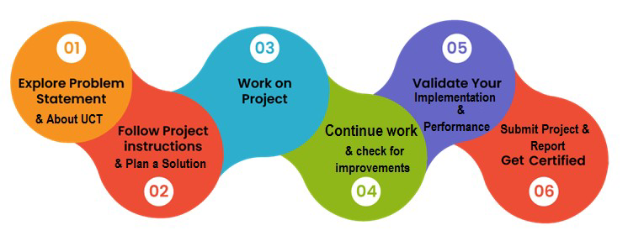

My Learnings and overall experience was good and look forward to learn more.

Thanks to all mentors who have helped to clear the doutes.

# 2 Introduction

## 2.1 About UniConverge Technologies Pvt Ltd

A company established in 2013 and working in Digital Transformation domain and providing Industrial solutions with prime focus on sustainability and RoI.

For developing its products and solutions it is leveraging various **Cutting Edge Technologies e.g. Internet of Things (IoT), Cyber Security, Cloud computing (AWS, Azure), Machine Learning, Communication Technologies (4G/5G/LoRaWAN), Java Full Stack, Python, Front end** etc.

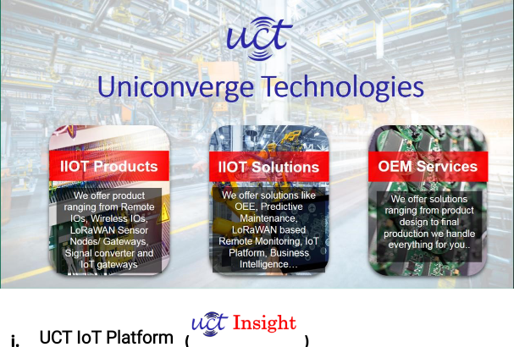

**UCT Insight** is an IOT platform designed for quick deployment of IOT applications on the same time providing valuable “insight” for your process/business. It has been built in Java for backend and ReactJS for Front end. It has support for MySQL and various NoSql Databases.

* It enables device connectivity via industry standard IoT protocols - MQTT, CoAP, HTTP, Modbus TCP, OPC UA
* It supports both cloud and on-premises deployments.

It has features to

* Build Your own dashboard
* Analytics and Reporting
* Alert and Notification
* Integration with third party application(Power BI, SAP, ERP)
* Rule Engine

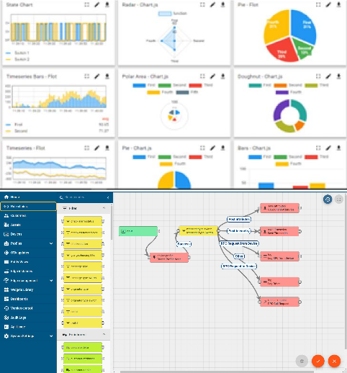

ii. **Smart Factory Platform (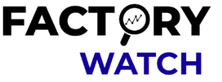)**

Factory watch is a platform for smart factory needs.

It provides Users/ Factory

* with a scalable solution for their Production and asset monitoring
* OEE and predictive maintenance solution scaling up to digital twin for your assets.
* to unleased the true potential of the data that their machines are generating and helps to identify the KPIs and also improve them.
* A modular architecture that allows users to choose the service that they what to start and then can scale to more complex solutions as per their demands.

Its unique SaaS model helps users to save time, cost and money.

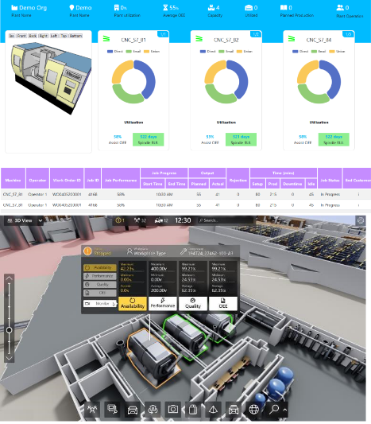

# iii. based Solution

UCT is one of the early adopters of LoRAWAN teschnology and providing solution in Agritech, Smart cities, Industrial Monitoring, Smart Street Light, Smart Water/ Gas/ Electricity metering solutions etc. iv. Predictive Maintenance

UCT is providing Industrial Machine health monitoring and Predictive maintenance solution leveraging Embedded system, Industrial IoT and Machine Learning Technologies by finding Remaining useful life time of various Machines used in production process.

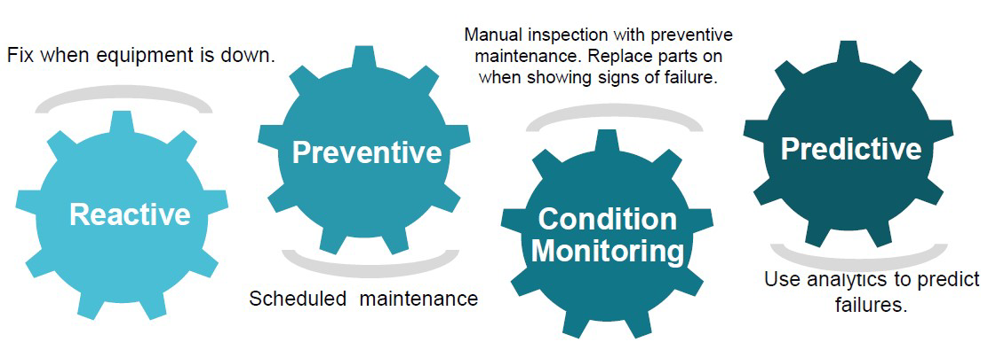

## 2.2 About upskill Campus (USC)

upskill Campus along with The IoT Academy and in association with Uniconverge technologies has facilitated the smooth execution of the complete internship process.

USC is a career development platform that delivers **personalized executive coaching** in a more affordable, scalable and measurable way.

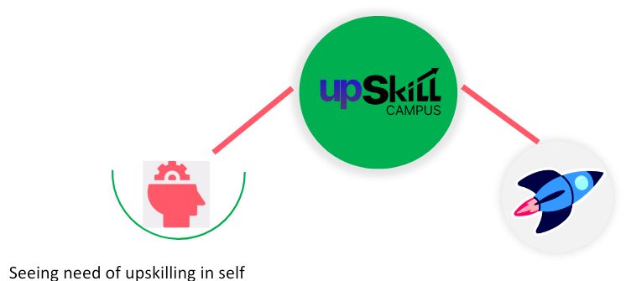upSkill Campus aiming paced manner along-with

to upskill 1 million additional support services e.g. learners in next 5 year

Internship, projects, interaction with Industry experts, Career

growth Services

# https://www.upskillcampus.com/

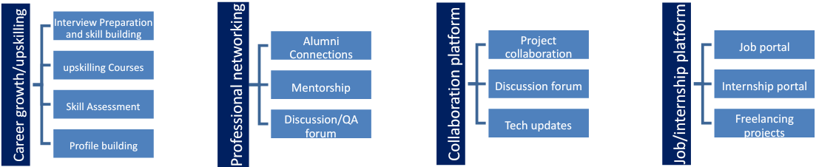

## 2.3 The IoT Academy

The IoT academy is EdTech Division of UCT that is running long executive certification programs in collaboration with EICT Academy, IITK, IITR and IITG in multiple domains.

## 2.4 Objectives of this Internship program

The objective for this internship program was to

☛ get practical experience of working in the industry.

☛ to solve real world problems.

☛ to have improved job prospects.

☛ to have Improved understanding of our field and its applications.

☛ to have Personal growth like better communication and problem solving.

## 2.5 Reference

[1] online website https://learn.upskillcampus.com/s/courses/64b90762e4b048608067b1b0/take?freecourseenrol=success&loginMsg=1

## 2.6 Glossary

| Terms | Acronym |
| --- | --- |
| EHR | Electronic health record |
| EP | Eligible professional |
| FHA | Federal health architecture |
| FHIR | Fast health care research |
| CP | Cerebral palsy |

## 3 Problem Statement

In the assigned problem statement

The large amounts of administrative and clinical data generated by providers have been seeing extensive growth in the past decade. Healthcare data management has shown itself to be a challenge as well as an opportunity to enhance healthcare IT security. Healthcare providers are using healthcare data management software to improve the quality and security of their care delivery services, improve healthcare solutions, uplift efficiency, meet regulatory compliance requirements, and achieve both short and long-term objectives. However, the challenges of using patient data in healthcare analytics need to be overcome. There needs to be an organized method of dealing with fragmented data, enabling its analysis, integrating it, and deriving necessary and relevant insights to ensure optimum security and privacy. Furthermore, health data management solutions need to be accessible. This is where healthcare data management, IT solutions, and digitization come into play.

Before learning about the challenges in provider data management solutions, let’s understand what is healthcare data management.

## What is Healthcare Data Management and How is it Significant?

Healthcare data management, commonly identified as Health Information management (HIM) is a form of systematic organization of data management in healthcare organizations. It is stored in digital format and it includes Electronic Health Records (EHRs), Electronic Medical Records (EMRs) generated for [provider appointments](https://mobisoftinfotech.com/products/appointment-scheduling-app-development), handwritten prescriptions, and medical notes scanned and kept in a healthcare repository.

The significance of health data management is not only tasked with the organization of medical data but also to integrate and enable analysis. This helps in improving patient care and providing more efficiency. Healthcare data management drives insights that improve health outcomes while protecting privacy in healthcare and cybersecurity.

According to experts:

* A large group of healthcare organizations collects claims data, EMR abstracts, enrollment data, and medical programs.
* Leading organizations utilize the capabilities of EMR feeds and disease management program data.
* Limited organizations use non-health data resources that utilize augmented formal medical data like remote monitoring, wearable devices, patient lifestyle information, and patient survey about their experience.

Once healthcare data management progresses beyond its capabilities, more organizations are expected to collect a vast variety of health-related information and data, integrate it to generate newer insights, and enhance patient health outcomes.

There are various challenges and benefits of health information and data. Let’s look at the challenges in healthcare technology.

## Challenges in Healthcare Data Management

Previously, health data management solutions were involved in purely paper-based tracking and then slowly transitioned into the digitized format as seen in current trends. Today, with healthcare management problems and solutions, much health information and data are yet to be digitized or not yet integrated into healthcare data management software.

Here are a few challenges in health information exchange in recent times.

### **Fragmented Data**

One of the many challenges in healthcare technology is that health data vulnerabilities include structured data. Structured data can be integrated into healthcare database management systems or saved as image and video files, stored in specialized formats (DICOM for MRI scans), scanned paper documents, and more. Data in healthcare is widely duplicated, stored, and collected multiple times in various versions across public health organizations, providers, pharmacies, patients, ad insurance bodies.

### **Data Changes**

One of the many organizational problems in healthcare is that health data is constantly changing including the names, locations, professions, and conditions of patients and providers. Patients constantly undergo numerous tests and are administered various treatment types over the years. Accordingly, the treatments and medication types change in the course as well. New types of health data management solutions include [telehealth](https://mobisoftinfotech.com/products/telemedicine-app-development-solution) modules creating new data types.

### **Regulatory Compliances**

Health data are sensitive material and very prone to health data breach. Healthcare organizations are required to adhere to government compliance and regulatory rules like [HIPAA](https://mobisoftinfotech.com/services/hipaa-consulting-services) and ADA. Data management for healthcare like data discovery faces challenges due to poor data quality making it difficult to perform during audits and regulatory requirement meets. This limits the resources from including diverse data of providers that may be beneficial for patient health.

### **Inadequate Data Integration Across Systems**

This continues to be one of the ongoing challenges in healthcare technology as various health data management systems can talk to one another to receive a comprehensive overview of the patient data.

### **Overload of Data**

Healthcare data can be overwhelming on healthcare data management software. Organizations and enterprises are required to invest in healthcare IT security infrastructure more effectively. Without adequate ecosystems and data governance, healthcare enterprises risk facing serious reputational and financial consequences.

Moving on to the health data management solutions that enhance healthcare IT security.

## Solutions to Meet Healthcare Data Management Challenges

Healthcare data management is known for its complexity. It comprises various processes like storage, data entry, AI, processing, accessibility, security, and predictive modeling. Some of these advantages of technology in healthcare help in implementing solutions, medical enterprises, facilitating, informing, and streamlining the processes. It includes –

### **Technologies for Data Entry**

Healthcare enterprises that use technologies for data entries to aggregate and collect data from various systems and resources in different formats. This helios in storing the data in a central repository. Providers are using IoT to remotely monitor patients through smart and wearable devices. Providers can collect and monitor data from their homes. Providers are using customer-relationship management (CRM) tools and platforms to understand patient needs and improve their holistic experience. OCR technologies enable providers to digitize the texts and minimize manual errors.

### **Access to Technologies and Data Storage**

Providers use data storage and have access to technologies like automated tasks, HIPAA compliance, improved access, and security. In place of using traditional on-premise geolocations, they are now towards safer and cloud-based solutions. Cloud data storage offers flexible information storage capacity and it comes with low maintenance cost. It also allows providers, stakeholders, and organizations to have easy access to adopting hybrid and remote work policies and mobile apps. Providers are allowed to increase or reduce this healthcare data management software space as needed instead of investing in on-premise platforms or servers. Coud-based technologies and other hosting solutions have a lower risk of health data breaches than on-premise servers as this data is stored in various other locations and is more secure.

### Data Security, Fraud Technology Detection, and Security

Process data in real-time is crucial to providers and healthcare organizations. Healthcare data management allows them to adopt newer technologies and healthcare database management systems as a lot of data needs to be collected and can be too much for traditional systems. This data stored comes in various resources and formats. AI and ML ate allowing providing to diagnose patients more accurately and forecast medical concerns and their progress. This helps in working in real-time, improving the overall efficacy of providers, doctors, and nurses, and helps in providing better health results for patients. For ensuring data management in healthcare, providers also need to ensure optimum data security. Implementing security technologies helps in controlling access and integrating encryption during storage or transmission.

Providers can now also use fraud detection and prevention systems for monitoring any suspicious activities that can be inspected more closely. Data-driven fraud prevention is now aided by artificial intelligence as it offers higher fraud prevention and detection power that is more cost-efficient for organizations.

### Optimum Scalability for Data Architectures

Healthcare data management enables providers to generate an exponential amount of data every second to mine it for valuable patient insights. With digital innovation and new technologies making headway toward availability, data output will grow further.

Healthcare professionals are adopting cloud storage and computing to predict inevitable future growth. On-premise storage methods are now limited as healthcare organizations and enterprises are investing more in provider data management solutions. Cloud-based solutions will provide optimum output for data architectures and scale up the business when new hardware is invested in.

## 4 Existing and Proposed solution

1. Expand Insurance to Cover Health Care Costs.
2. Extend Telehealth Services.
3. Invest in Mobile Clinics.
4. Educate the Public About Multiple Health Care Sites.
5. Improve Cultural Responsiveness.

**4.1 Code submission (Github link)**

**4.2 Report submission (Github link) :** first make placeholder, copy the link.

## 5 Proposed Design/ Model

Given more details about design flow of your solution. This is applicable for all domains. DS/ML Students can cover it after they have their algorithm implementation. There is always a start, intermediate stages and then final outcome.

**5.1 High Level Diagram (if applicable)**

**Figure 1: HIGH LEVEL DIAGRAM OF THE SYSTEM**

**5.2 Low Level Diagram (if applicable)**

### 5.3 Interfaces (if applicable)

Update with Block Diagrams, Data flow, protocols, FLOW Charts, State Machines, Memory Buffer Management.

## 6 Performance Test

This is very important part and defines why this work is meant of Real industries, instead of being just academic project.

Here we need to first find the constraints.

How those constraints were taken care in your design?

What were test results around those constraints?

Constraints can be e.g. memory, MIPS (speed, operations per second), accuracy, durability, power consumption etc.

In case you could not test them, but still you should mention how identified constraints can impact your design, and what are recommendations to handle them.

**6.1 Test Plan/ Test Cases 6.2 Test Procedure 6.3 Performance Outcome**

**7 My learnings**

You should provide summary of your overall learning and how it would help you in your career growth.

## 8 Future work scope

You can put some ideas that you could not work due to time limitation but can be taken in future.